WELCOME TO



HEADINGTON QUARRY FOUNDATION STAGE SCHOOL

4 Quarry School Place,
Headington Quarry,
Oxford
OX3 8LH

TELEPHONE/FAX: 01865 762345
DAYCARE MOBILE: 07982696990

e-mail:
office.1006@headington-nurs.oxon.sch.uk

Website:
www.headingtonquarry-nursery.org.uk

WELCOME TO HEADINGTON QUARRY FOUNDATION STAGE SCHOOL

Dear Parents and Families

We welcome you and your family to our school and hope that your child will have a happy time here. Children’s earliest experiences of learning, lay the foundations not only for later learning in school, but also for their self-confidence and belief in themselves as learners for their whole lives.

We believe that parents are the first and most important educators of their children, and we look forward to a close and successful partnership with you during the coming terms.

This prospectus gives information about the school, its aims and curriculum. If there is anything else you would like to know, please do not hesitate to ask, we will be happy to help.

Natalie Wilson
Headteacher

HEADINGTON QUARRY FOUNDATION STAGE SCHOOL

Headington Quarry Foundation Stage School is an Oxfordshire County Council maintained Nursery School, which also houses St. Andrew’s Church of England Primary School’s Reception Class.
We offer education places of 15 hours over 5 days per week, term - time only. We also offer some 30 hour places.The nursery place may be added to with paid wraparound daycare from 8.00-5.30 each day and during the school holidays.

The school accepts children aged 3-5 years, admitting children in the term after their third birthday.
If you would like your child to attend Headington Quarry Foundation Stage School, you should register his/her name on the admission waiting list as soon as possible after he/she is two years old by contacting the school office.

We follow the Local Authority advised ‘Maintained Nursery School’s admissions’ policy which is available for reading on the school website or paper copy from the school office. We prioritise local children and those with special educational needs and disabilities, social needs and other Local Authority agreed criteria. Children and families at Headington Quarry School are from a wide range of social, cultural, economic, linguistic and racial backgrounds. The children include those who may have a range of special educational needs and disabilities. We respect and value this diversity and much of our curriculum springs from this richness. We believe that all children should grow up together learning to enjoy and respect other people’s differences.
Parents will need to apply separately for a Primary School place in the academic year in which your child turns 4 years old , in order for your child to begin Primary school (Reception Class) in the academic year in which they turn 5 years old. Oxfordshire County Council’s Admission team inform the school of application dates which we pass on to parents in the Autumn term.

HISTORY OF THE SCHOOL
Headington Nursery School was originally in Beech Road in Headington and moved to the William Kimber site in 1958. In July 2003 we were fortunate to be able to move into Headington Quarry C of E school site here in Quarry School Place. This school was built in 1864 for primary aged children and quickly became a central part of Quarry area life. However pupil numbers fell and when the school was closed in 2003 it became an ideal opportunity for Headington Nursery School to be relocated.
It is a beautiful light and airy building which successfully manages to accommodate young children.
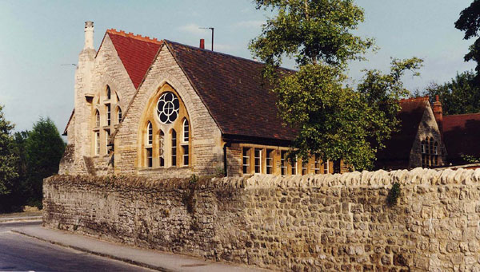

SCHOOL ORGANISATION

From the beginning of the (long) term after a child’s 3rd birthday there is a “Universal” Entitlement to 15 hours per week (during term time) of free childcare. From 1st September 2017 there will also be an “Extended” entitlement of 30 hours per week (during term time) for children whose parents meet eligibility criteria specified by the Department for Education. All parents with 3 and 4 year old children qualify for the Universal Entitlement. We aim to give children at least three terms here before they go to Primary school –this gives children a good opportunity to make relationships with adults and children, to become established members of the school community and to have plenty of time to build on their learning.

SESSION TIMES

Universal 15hour times

Morning session 8.30 a.m. - 11.30 a.m.

Children’s lunch time 11.30 a.m- 1.00 p.m

Afternoon session 12.30 p.m. - 3.30 p.m.

Extended entitlement times (30 hours) 2 groups 8.45-2.45 and 2 groups 9.00-3.00pm

If you are unavoidably held up and cannot arrive in time, please telephone
to let us know so we can warn your child and avoid distress.

Supplementary Hours (wraparound care)

Our daycare is open from 8.a.m until 5.30 p.m and information about costs are available from the school office. We also run a holiday play-scheme during the school holidays, apart from 2 weeks in the Summer and the Christmas and New Year period.

ATTENDANCE
Nursery school for three year olds is not statutory, but your child will get much more out of it if you attend regularly. Your child will find it much easier to make friendships if s/he comes regularly and their group times are planned across the whole week.

ALLERGIES
It is essential to inform us if your child has any allergies or food intolerances, and any changes. We need to see a letter from a health professional before excluding any foods for them.

THE SCHOOL DAY

When children start our school they join a group of children with a Key Person who is specifically trained to work with young children. The children remain with the same Key Person during their time in the Nursery to support their emotional security and to help staff get to know families .
At the beginning of each session the children join their Key Person for registration and a short group-time session. The Key Person then explains the activities available for that day and talks to the children about what they could do .
There are always a wide range of activities on offer to cover all seven areas of the Early Years Foundation Stage Curriculum. The large outdoor area is as important a classroom as the inside area, and children are encouraged to try activities from all areas of the curriculum, outside as well as in as they have access to indoor and outdoor activities most of the time .
Towards the end of the session, children re-join their Key Group for story, singing, music or discussion.
We follow Oxfordshire school term dates and have 5 In-service training days for staff (INSET days) during the year. These are determined on an annual basis and you will receive prior notice of term dates.

DAY CARE & WRAP-AROUND
We are pleased to be able to offer extended times which families can pay for, to give your child extra time in school. HQFSS Daycare offers a caring, happy , stimulating and well equipped childcare facility, led by dedicated and qualified staff .The extended services include lunchtime, before and after school care, and an additional session (for instance if your child has a morning school place you can book the afternoon session as paid wrap-around daycare). Our intention is to make these additional hours as flexible as possible for parents. We operate a weekly booking system and payment must be made at the time of booking on the preceding Thursday. Daycare is also available during the school holidays. If your child is using the extended entitlement (30 hours place), then any supplementary hours will need to be booked a term in advance.
A table of charges for these additional times is available from the office along with details of how working parents can apply for some of their childcare costs with child-care voucher schemes etc.

ADULTS IN SCHOOL

TEACHERS

Headington Quarry Foundation Stage School has a Headteacher, a full-time teacher in Rainbow Class and teachers within the Nursery. Teachers in maintained Nursery Schools have the same level of teaching qualification as their primary and secondary colleagues and are required to have a specialism in Early Years Education

NURSERY NURSES
Nursery Nurses have all completed the training required to obtain the NNEB or NVQ 3 certificate, a two-year qualification which encompasses child development, health and education of babies and children up to seven. Several of our staff have gone on to achieve Early Years Professional Status.
NVQ 3 / 2 qualified staff work in our daycare. Staff and children in daycare work/play with the nursery staff and children in an integrated way for most of the day.

TEACHING ASSISTANTS

Several teaching assistants are employed in school, to support identified children with particular needs. Teaching assistants undertake Local Authority training and take part in school in-service training and planning.

SUPPORT STAFF

Teaching staff depend on the hard work of the school secretary, daycare administrator, cleaner-in-charge, cook and lunch-time supervisors to keep the school working efficiently in all areas .

STUDENTS

We have links with Oxford Brookes and regularly have teaching students on placement here. We also have students of NVQ 2 and 3 courses at times. We agree with local secondary schools the placement of school students for short periods of work experience during the year. The school benefits from these different skills and backgrounds whilst providing important training for all students alongside experienced staff. We often receive requests for research to be carried out with the children but you will always be asked for your permission for this to take place.

GOVERNORS

The School Governors play an important part in the life of the school. They work closely with the Headteacher and have a general responsibility for overview of every aspect of the school, its activities and its welfare. They meet regularly to discuss the curriculum and other issues concerning the management of the school, and to appoint staff when necessary.
Elected Parent Governors offer parents an important channel of communication and the opportunity to take part in the running of the school. Parent Governors generally serve for four years but may stand down when their child goes on to primary school. Please talk with the parent governors for any support or advice about the school. The names and photo’s of these are in the reception area of the school and names are updated on the web-site.
The Governors are required to prepare an Annual Report to parents during the summer term.

PARENT TEACHER ASSOCIATION

The school PTA has organised a wide range of celebrations and entertainments all to raise funds for the school and to develop opportunities for parents and families to socialise. All parents are encouraged to join in and contribute in some way to make this a vibrant and supportive part of school life.

HOW YOUNG CHILDREN LEARN

The current Early Years Foundation Stage was put in place from September 2012, and is used in all early years settings, for children from Birth to 5 years.
We believe that children learn best through play by active investigation and exploration with time to discover, wonder and use their senses to find out about the world around them.
We provide a broad curriculum which supports all aspects of the child’s development-social, emotional, creative, physical, intellectual and linguistic. It includes the early stages of reading and writing, maths, science, physical development and humanities, and wide variety of creative skills.
Promotion of equal opportunities, and inclusion of children ,whatever their abilities and needs, is central to all our work.
Each term we develop plans based on observations of children’s interests and needs which provide a focus for the resources and experiences. There is a wide range of ongoing school experiences: cookery, visual and other arts, sand and water, construction, role-play, outdoor play activities and a great deal more. We believe that children need to be happy in order to learn, confident to try out ideas and encourage learning dispositions such as curiosity, perseverance and problem-solving. We provide lots of hands-on and real-life experiences such as vegetable gardening.
Through our provision, we hope to ensure that children gain the skills, knowledge and attitudes that they need to make sense of the world around them. We promote learning methods that encourage success and help the child to develop independence in decision making. For children, learning is an integrated process (i.e. not compartmentalised into subject areas): adults in school strive to find different ways of supporting children’s learning.

The four themes of the Early Years Foundation Stage are firmly embedded into our practice and daily planning:
A Unique Child :based on the principle that every child is a competent learner from birth who can be resilient, capable, confident and self-assured
Positive Relationships: children learn to be strong and independent from a base of loving and secure relationships with parents and/or key person
Enabling Environments: the environment plays a key role in supporting and extending children’s development and learning
Learning and Development: children develop and learn in different ways and at different rates and all areas of Learning and Development are equally important and inter-connected

There are three Characteristics of Effective Learning which underpin our approach to teaching children:
Playing and Exploring which includes finding out and exploring, playing with what they know & being willing to have a go.
Active Learning which includes being involved and concentrating, persistence, enjoying achieving what they set out to do
Creating and Thinking Critically which includes having their own ideas, making links and choosing ways to do things

There are seven areas of the curriculum at the basis of our planning which we develop from the ongoing observations of the children. These outlines of each area of the curriculum describe what many children will be achieving when they are 5 years old: some may achieve all of it sooner, others may need longer.

All areas of learning and development are important and inter-connected. Three areas are particularly crucial for igniting children’s curiosity and enthusiasm for learning, and for building their capacity to learn, form relationships and thrive. These three areas, the prime areas, are:

• communication and language
• physical development
• personal, social and emotional development

There are four specific areas:
• literacy
• mathematics
• understanding the world
• expressive arts and design

• Communication and language development involves giving children opportunities to experience a rich language environment; to develop their confidence and skills in expressing themselves and to speak and listen in a range of situations.
• Physical development involves providing opportunities for young children to be active and interactive; and to develop their co-ordination, control, and movement. Children are also helped to understand the importance of physical activity, and to make healthy choices in relation to food.
• Personal, social and emotional development involves helping children to develop a positive sense of themselves, and others; to form positive relationships and develop respect for others; to develop social skills and learn how to manage their feelings; to understand appropriate behaviour in groups; and to have confidence in their own abilities.
• Literacy development involves encouraging children to link sounds and letters and to begin to read and write. Children are given access to a wide range of reading materials (books, poems, and other written materials) to ignite their interest.
• Mathematics involves providing children with opportunities to develop and improve their skills in counting, understanding and using numbers, calculating simple addition and subtraction problems; and to describe shapes, spaces, and measures.
• Understanding the world involves guiding children to make sense of their physical world and their community through opportunities to explore, observe and find out about people, places, technology and the environment.
• Expressive arts and design involves enabling children to explore and play with a wide range of media and materials, as well as providing opportunities and encouragement for sharing their thoughts, ideas and feelings through a variety of activities in art, music, movement, dance and role-play.

CHILDREN'S RECORDS and ASSESSMENT

Parents complete a form when children make an initial visit to school. This gives an opportunity to explain about each child’s interests and talents and anything which parents feel might be a concern. Your child’s Key Person will discuss this with you on your visits.
During their time in school, each child’s Key Person keeps detailed observational profiles on the children in their groups and contribute to records on all children. They have regular discussions with parents to share children's progress with parents. Close observation of children enables teachers to plan appropriately for their next steps.
When your child leaves the Nursery you will receive a report summarising his/her achievements in the curriculum. A profile/report for each child will be forwarded to the next school/setting which your child will attend .

CONTINUITY and MOVING ON TO PRIMARY SCHOOL

We have established very successful links with all our local schools. The teachers
from most of these schools visit children here before they start in the Reception or
Year One classes. Visits are arranged for you to take your child to their new school by the primary school. From September 2004, St Andrew’s C.E. Primary School (on London Road) has placed its first class, (Reception class )on our school site.
Children who are going to go to St. Andrew’s for their primary education will
therefore have the opportunity to spend up to eight terms here, gradually progressing
through the Foundation Stage in one setting. Please talk to the Headteacher at St. Andrew’s Primary School or at Headington Quarry Foundation Stage School if you would like to know more details about this arrangement.
Having a place at Headington Quarry School does not automatically
entitle your child admission to St. Andrew’s Primary School
Parents will have to apply for Primary school places in the Autumn term of the year in which your child turns 4 years old as they will be able to start primary school from Autumn in the year in which they turn 5 years. Parents have the right to defer the place and thereby keep the child at Nursery ,also fulltime, until you want to take up the offer of the primary school place.

If you require further information e.g. on age of entry for your child to school, call
Oxfordshire County Council’s Early Years Information Line on 01865-815175
Oxfordshire’s Family Information Service : 882288
Website: admissions.schools@oxfordshire.gov.uk

SCHOOL POLICIES

SEX EDUCATION

Sex education is not taught as a separate subject, but is dealt with as it arises
e.g. answering children's questions following the birth of a younger brother or sister,
or during a theme about 'Ourselves'.
We place a firm emphasis on sexual equality e.g. boys are encouraged to play in the home-corner, use dressing up clothes, help with tidying up; girls are encouraged to use construction equipment, woodwork, wheeled toys. We choose books that show men and women in a variety of roles, rather than those that are stereotyped e.g. only women doing housework, being nurses or only men mending things or going out to work.

INCLUSION AND SPECIAL EDUCATIONAL NEEDS AND DISABILITY (SEND)

The school welcomes and supports children who need special provision to enhance and develop their learning, for example children with behaviour or learning difficulties; children with mental health problems; children with physical disabilities; children who are particularly able. These children may be supported through work in small groups, or individual time with an adult. The school is fully accessible to children or adults who use wheelchairs.

We have strong links with external agencies, for example health visitors, a school psychologist, speech therapists and preschool counsellors. If, following discussion with parents, we feel other professional advice would be helpful, they are always happy for us to call on their services. We have a named Special Educational Needs and Disability (SEND) Co-ordinator who ensures differentiation is accurately planned to support each child. There is a named governor who is available to speak with parents as well.

Parents of children who are considered to have SEND will always be included in making arrangements to meet those special needs. Please talk to the Headteacher or your Key Person if you have a particular concern about your child. Our SEND Policy and Information Report are available on our website.

RACIAL EQUALITY AND ANTI-RACISM

Headington Quarry Foundation Stage School is committed to promoting racial equality and to minimising the effects of harmful stereotypes by encouraging children to learn about the similarities and differences between us all. We use books and other resources which reflect our wide cultural community and deal with incidents of racial abuse by discussing concerns with parents. Please ask if you would like to see our policy on racial equality, or look on the website. Our school has many children who speak languages other than English and the professional understanding of the staff supports their development. Some children take time to settle in and feel able to attempt speaking in English- they may be watching and listening as their confidence grows. Our resources and learning experiences reflect modern Britain and support British values.

SAFEGUARDING CHILDREN & CHILD-PROTECTION

Our whole school community has a duty to safeguard and promote the care and welfare of children. We have a policy and procedures are in place and all staff are regularly trained in the most current Safeguarding approaches.
The school is committed to work in partnership with Oxfordshire Safeguarding
Children Board and other agencies on child-protection issues. The needs and safety of the child are always at the centre of our thinking. We believe that children have the right to feel safe and protected from any form of abuse and aim to provide a caring environment which nurtures children’s self-esteem and autonomy. Investigation is the responsibility of the Children & Families Assessment team and police, not the school. If a child who has a child protection plan leaves our school information will be forwarded to the new school immediately and child’s social worker will be informed. We strongly encourage partnership between parents and other agencies if support is needed. All our staff and volunteers have to undergo an enhanced DBS check and are fully trained in safeguarding procedures. We adhere to Local Authority Safe Recruitment guidelines.
The Safeguarding Children Policy is on the school website and is available from the school office. Please come and see the Headteacher, Kelly Welch, Katherine Cooper or Briony Wood (designated safeguarding leads) about any concerns in this area.

We do not release children to unknown adults and require written permission for someone else to collect your child except for extreme circumstances. Each key group has a communication book in which written permission should to be recorded by the parent.

Change of address/telephone numbers
Your will be asked to fill in an admission form and individual information about your child with you when she/he first starts at school. Please make sure that we have a telephone number for use if we are unable to contact you at home in an emergency. It is important to let us know if either your address or phone number changes, or if someone other than you will be bringing/collecting your child

PARENTS/CARERS IN THE SCHOOL

You are most welcome to spend time in School with your child, and it is helpful for all the children if we have extra adults to get involved with them in their play. We usually find that it works best if you come in after your child's first term, so that they are securely established on their own before your visits.
You may like to stay and do a specific job, e.g. cooking, helping
with woodwork, etc. We always need extra people to read books to children in the book-corner. If you would like to do this please talk to your child's group leader. Grandparents, Aunts or Uncles are welcome too!). Please let us know your skills, enthusiasms and talents- more or less any interest will be something children will enjoy sharing.If you are happy to help on a regular basis you will be very welcome. We will need to obtain DBS clearance for you if you are helping regularly.

Parents are their child's first educators and we believe that parents and staff are partners in children's education and close home/school links are vital. We have an "open door" policy, so that parents can spend time with their children while they are here. We send regular newsletters so that parents are kept informed about all that is going on.
Please let us know if you have any concerns, large or small, about your children’s progress or happiness. Staff are available briefly at the beginning of each session but it is usually easier to talk to your child’s key person at the end of the session. Either the key person or the Headteacher will always try to be available on the same day on which you wish to speak to them

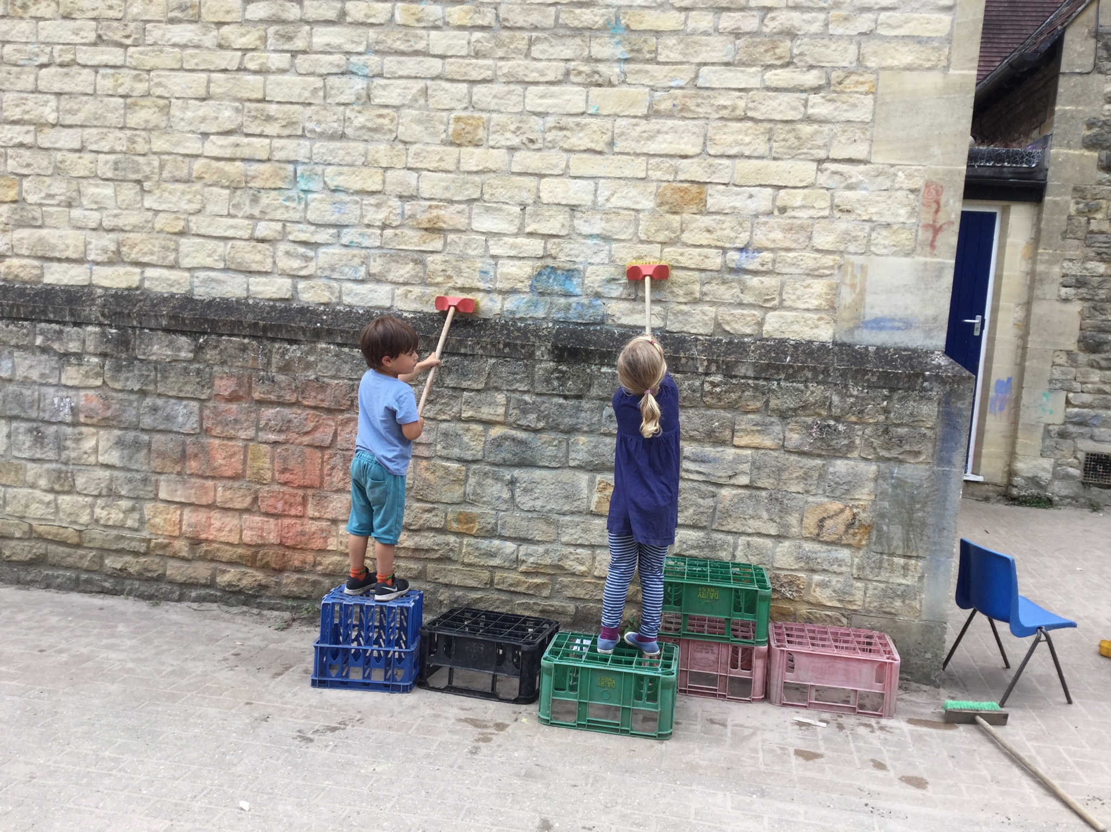

BEHAVIOUR IN SCHOOL AND SCHOOL RULES

An important (arguably the most important ) aspect of learning for three-five year old children is that of Personal, Social and Emotional Development. It is in mixing with lots of other children and adults that children gain confidence, begin to learn about themselves, and to feel part of a community away from home for the first time.
Part of this learning is about the needs and feelings of other people: most children need help to start with to understand that others feel as they do and that similar things hurt them or make them happy. We aim to help children to understand and to talk about their feelings, and at the same time to realise that some actions are not acceptable.
We talk to children about the need to have rules ‘so that everyone can be happy’, and discuss the behavioural expectations with children. We frame this positively, i.e. talking about what we do rather than what we don’t do and usually expressed as “We are kind to each other”. If children are finding it difficult to play cooperatively and have been reminded about our rules once or twice, they will leave the activity/area for a short time until they feel able to continue. If we are finding that a child is having significant difficulties with behaviour our first action will be to discuss the problem with parents. We have an escalation procedure which will be supported by external agencies such as the Local Authority Educational Psychologist and Behaviour Support team.

MEETING STAFF

Please feel free to discuss your child's progress with your child's key person . The staff are available at the end of each session , or by appointment at other times during the week. Staff are also contactable by classdojo. Please come to talk with the Headteacher about anything urgent at any other time as well. We offer termly parent consultations where you can meet with your Key Person as well.

HEALTH AND SAFETY AND FIRST AID PROCEDURES

If your child is going to be absent, please ring school to let us know when she/he is likely to return.
Children who are ill with sickness/diarrhoea should be kept at home for
forty eight hours after the symptoms cease.
If your child is unwell please keep him/her at home even if she/he asks to go
to school. Your child is much better off at home where they can sit quietly and not spread infection to other children. Please let us know about any infectious diseases especially if anyone has German Measles (Rubella). There are clear guidelines for infectious conditions produced by the Health Protection Agency which we are obliged to abide by for the health and safety of all children and staff. HQFSS provides a stimulating and challenging learning environment for young children. Alongside these physical opportunities there will inevitably be accidents. We
have many Paediatric trained First Aiders and all staff are vigilant for potential dangers in the environment. We record all accidents/incidents on a form which we share with parents and ask to be signed which we keep to analyse the pattern of accidents . In the event of more serious injuries we contact parents, who take the child to a doctor or hospital as appropriate. If we are unable to contact a child's parents a member of staff will do this. In the event of major injury or illness which clearly requires immediate hospital treatment, the emergency services will be contacted and the arrangements for transfer to hospital carried out before contacting the family.

MEDICINES

We have a full Medicine Policy which is on the website or available in hard copy on request. We will only give children prescribed medicine and have permission procedures to administer them. We recommend that any medicine is given to children before and after school hours in order to eliminate the need for this.

HEALTHY SCHOOL AND HEALTHY EATING

We ask that parents bring in contributions of fruit and vegetables for snack time. Children join a table where a selection of fruit/vegetables, milk or water is available so that children can choose when they wish to participate. Staff support with hygiene and how to take turns and share as well as using this informal group for general talk.
Our school lunches are cooked on site by a cook trained in cooking healthy , balanced diets for young children. There is always a vegetarian option and the meals reflect a range of children’s cultures. Children are encouraged to try food but never made to eat.
Meals are seen as social occasions as children sit in family groups with and adult so learning about being in a group other than their family and use of appropriate skills socially etc. We make place mats with each child with their photo and name to help with their sense of belonging to that group. We grow fruit and vegetables in our thriving vegetable garden which helps children understand the growing process as well as helping to encourage them to try more fresh food.
Please speak to your child’s key person about any dietary requirements.
Please see the office staff if you are eligible for Free School meals.

Lunchtime places are available on request as part of our daycare/wraparound provision, for those children who have the universal entitlement. The cost for this is made up of two parts: the meal (a hot meal prepared on site by our cook), and the care element for the extra hour and a half.
The menus are posted on our school web-site and on school notice-boards. As menu’s are organised centrally by Caterlink our cook adapts and amends some of the choices and menus to suit our age range.

EARLY YEARS PUPIL PREMIUM
From April 2015 the school can claim extra funding through Early Years Pupil Premium to support children’s development, learning and care. There is a separate form for parents to complete included in the prospectus pack.

CHARGING FOR ACTIVITIES

There is no charge for day-to-day activities in school.
If we go on trips we ask for voluntary contributions to cover the costs
or trips may have to be cancelled if the contributions received do not cover the cost of the trip. (The school will support cases of hardship and will allow payments in instalments by prior arrangement.)
The Governors' policy on charging is available at from the office.

CLOTHING

It is helpful if you send your child to school in comfortable, loose clothing which can be undone easily when he/she goes to the toilet. Aprons are provided for paint, gluing activities etc. but accidents can still happen, so it is best if the clothes are washable and not too 'special'. Please name all clothing clearly.
We consider outdoor play to be an important part of our curriculum and, as long as the ground surface is safe, we go out in all weathers. Your child needs a warm coat, suitable boots/shoes, gloves and hat so that he/she can enjoy the outdoors without getting cold. Equally in summer months we ask parents to put sun-cream onto children or agree for us to do so. We also encourage children to wear hats and longer sleeved tops when hot for maximum protection.
Please encourage your child to be independent about putting coats on
and off - we have lots of children to help!

BOOKS AND STORY- SACKS

We have an excellent range of books and story sacks which you are encouraged to borrow, take home and share with your child . We ask you to sign for them and just let us know if anything happens to them!

USEFUL THINGS

We can always make use of the following items:
- 'Junk' for modelling, e.g. empty boxes, cartons, yoghurt pots, bottle tops, corks,
- kitchen roll tubes, egg boxes, etc.
- Wool, fabric scraps, string.
- Any paper suitable for drawing or writing, coloured paper.
- Card, birthday/Christmas cards, scraps for collage work, large newspapers

FOREST SCHOOL

Forest School is an opportunity for a group of children to visit a safe local area of woodland once a fortnight. We aim for all children at the Nursery to experience Forest School during their time here. We welcome parent/carer support on these visits.
They walk to the site with their trained Forest School leader and a member of staff: once there they are able to move around by themselves, play independently and explore the environment.
There are lots of interesting things to look at (including lots of bugs!) and the children have a real opportunity to engage with the natural world which this helps to develop their self-confidence and knowledge and understanding of their world

COMPLAINTS PROCEDURES

If you are unhappy about any aspect of the school, it is helpful if you discuss this with the Headteacher first of all. If you feel, following this discussion, that you wish to make a formal complaint, please see our complaints policy.

INFORMATION AVAILABLE IN SCHOOL

The following documents are available in school and on the website-Admissions Policy; Health and Safety Policy; Special Educational Needs and Disability Policy; Equal Opportunities Policy; Equality Statement; Safeguarding Children in Education Policy, Governors Annual Report to Parents : OFSTED Inspection Report December 2018

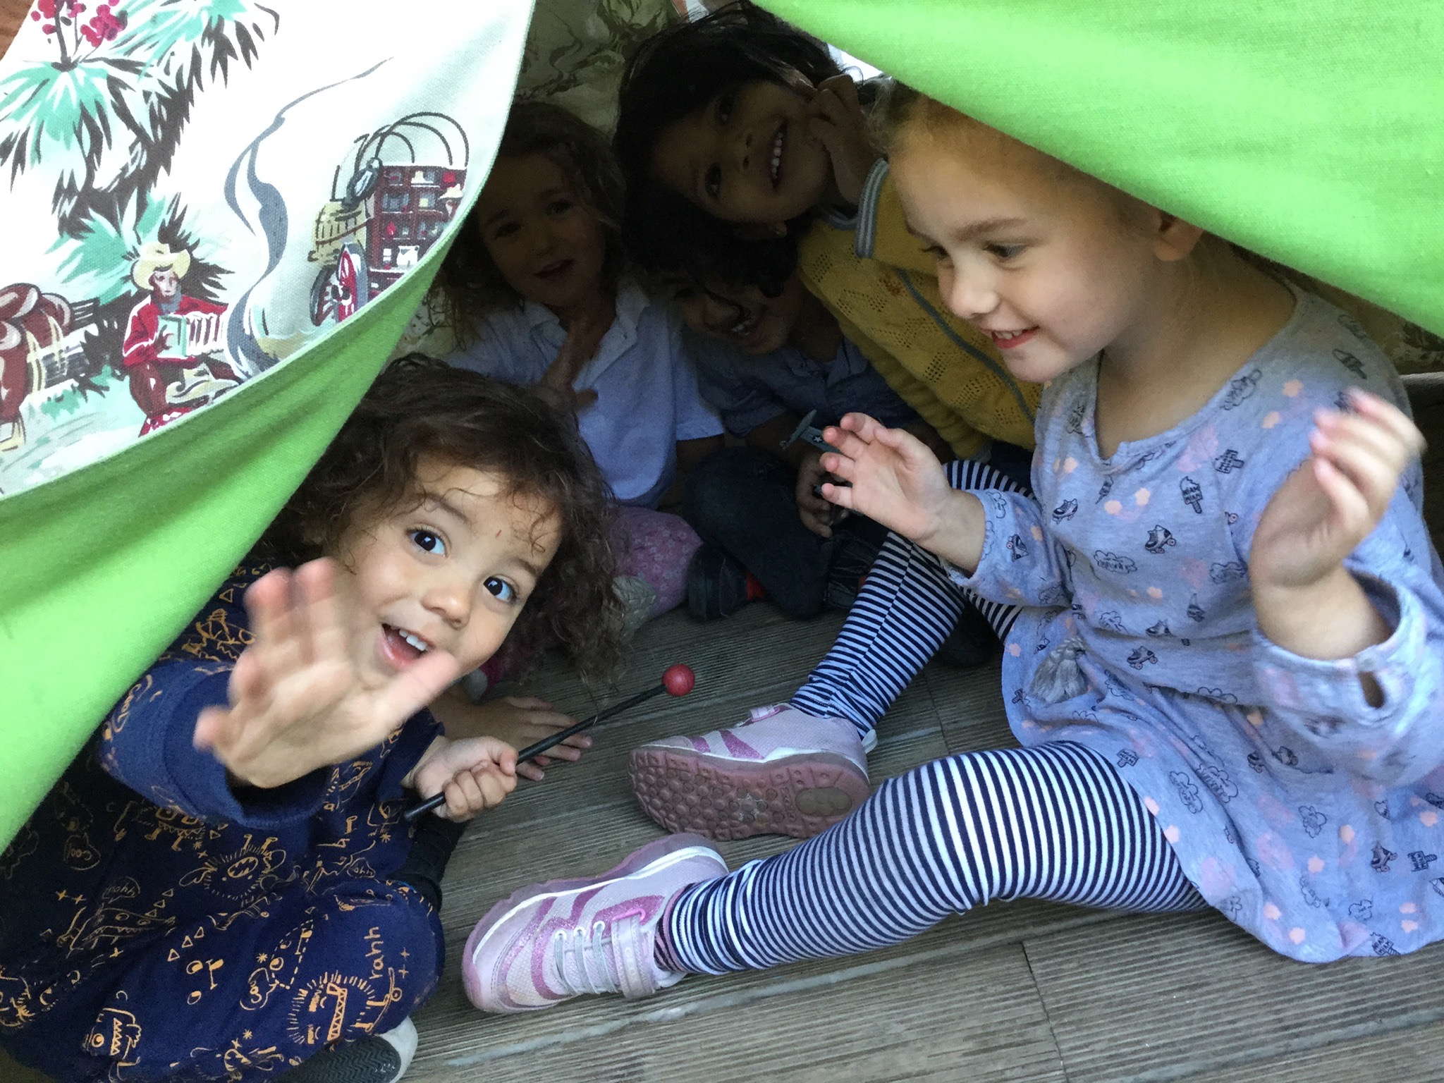

Privacy Notice (How we use pupil information)

Why do we collect and use pupil information?

We collect and use pupil information under the General Data Protection Regulations 2018. Particularly under Article 6, where the information is collected and used because it is required by our academies in order to carry out the task of educating and ensuring the welfare of our pupils.

We also collect and use pupil information in order to help pupils with additional special needs and requirements, so that we can ensure we offer the best possible support and resources to them (and their parents and carers) during their time in our school.

We use the pupil data to:

- Support pupil learning
- Monitor and report on pupil progress
- Provide appropriate pastoral care
- Assess the quality of our teaching
- Comply with the law regarding data sharing

The categories of pupil information that we collect, hold and share include:

- Personal information (such as name, unique pupil number and address)
- Characteristics (such as ethnicity, language, nationality, country of birth, and free school meal eligibility)
- Attendance information (such as sessions attended, number of absences and absence reasons) although this is non-statutory in early years.
- Relevant medical information
- Assessment information
- Special educational needs information
- Exclusions/behavioural information

Collecting pupil information

Whilst the majority of pupil information you provide to us is mandatory, some of it is provided to us on a voluntary basis. In order to comply with the General Data Protection Regulation, we will inform you whether you are required to provide certain pupil information to us or if you have a choice in this.

Storing pupil data

We hold pupil data for early years pupils until they leave our school to move on to Primary School.

Who do we share pupil information with?

We routinely share pupil information with:

- Schools that the pupil will attend after leaving us
- The local authority (Oxfordshire County Council)
- The Department for Education
- NHS – professionals involved in particular pupils

Why we share pupil information?

We do not share information about our pupils with anyone without consent unless the law and our policies allow us to do so. We share the pupils’ data with the Department for Education (DfE) on a statutory basis. This data sharing underpins our school funding, educational attainment policy and monitoring.

We are required to share information about our pupils with the DfE under regulation 5 of The Education (Information About Individual Pupils)(England) Regulations 2013.

Data Collection requirements:

To find out more about the data collection requirements placed on us by the DfE (for example – via the school census) go to https://www.gov.uk/education/data-collection-and-censuses-for-schools.

The National Pupil Database (NPD)

The NPD is owned and managed by the DfE and contains information about pupils in schools in England. It provides invaluable evidence on educational performance to inform independent research, as well as studies commissioned by the Department. It is held in electronic format for statistical purposes. This information is securely collected from a range of sources including schools, local authorities and awarding bodies.

We are required by law, to provide information about our pupils to the DfE as part of statutory data collections such as the early years census. Some of this information is then stored in the NPD. The law that allows this is the Education (Information About Individual Pupils)(England) Regulations 2013.

To find out more about the NPD, go to https://www.gov.uk/government/publications/national-pupil-database-user-guide-and-supporting-information.

The department may share information about our pupils from the NPD with third parties who promote the education or well-being of children in England by:

- Conducting research or analysis
- Producing statistics
- Providing information, advice or guidance

The Department has robust processes in place to ensure the confidentiality of our data is maintained and there are stringent controls in place regarding access and use of the data. Decisions on whether the DfE releases data to third parties are subject to strict approval processes and based on a detailed assessment of –

- Who is requesting the data
- The purpose for which it is required
- The level and sensitivity of data requested
- The arrangements in place to store and handle the data

To be granted access to pupil information, organisations must comply with strict terms and conditions covering the confidentiality and handling of the data, security arrangements and retention and use of the data.

For more information about the DfE’s data sharing process please visit –
https://www.gov.uk/data-protection-how-we-collect-and-share-research-data

For information about which organisations the DfE has provided pupil information (and for which project) please visit the following website –
https://www.gov.uk/government/publications/national-pupil-database-requests-received

To contact DfE – https://www.gov.uk/contact-dfe

Requesting access to personal data

Under data protection legislation, parents and pupils have the right to request access to information about them that we hold. To make a request for your personal information or be given access to your child’s educational record, contact in writing the Headteacher outlining your request.

You also have the right to –

- Object to processing of personal data that is likely to cause, or is causing, damage or distress
- Prevent processing for the purpose of direct marketing
- Object to decisions being taken by automated means
- In certain circumstances, have inaccurate personal data rectified, blocked, erased or destroyed
- Claim compensation for damages caused by a breach of the data protection regulations

If you have a concern about the way we are collecting or using your personal data, you should raise your concern with us in the first instance or directly to the Information Commissioner’s Office at https://ico.org.uk/concerns/

Contact – Out Data Protection Officer is
Our DPO is Darrell Smith and is contactable via Darrell.smith@turniton.co.uk Tel: 01865 597620

If you would like to discuss anything in this privacy notice – please contact

Headteacher
Headington Quarry Foundation Stage School
4 Quarry School Place
Headington
Oxford OX3 8LH
Telephone – 01865-762345
Email – head.1006@headington-nurs.oxon.sch.uk

Ofsted Inspections

Headington Quarry Foundation Stage School is regulated by Ofsted who carry out a full school inspection for all aspects of the school.

In December 2018 we were inspected by Ofsted: the reports are available from the Ofsted website (www.ofsted.gov.uk) –if you have no Internet access please ask in school for a copy.

There are four categories for OFSTED inspections: ‘Outstanding’, ‘Good’
‘Requires improvement’ and ‘Inadequate’. The school was judged to be overall an outstanding school.

Some comments from the report:

‘Your school gives children a superb start to their education. Staff develop children’s wonder in learning very effectively’.
‘Staff at your school have a deep understanding of the principles of early years education. Every day brings new surprises and challenge. Staff know about the importance of providing experiences that fascinate children’.
‘This is an outstanding school; each child is treated as an individual and with respect by the staff. The teaching is excellent and we are continually impressed by the leaps and bounds my son has made in his learning.’

